TASK 1: Evaluating Logistic Regression vs. Random Forest on Non-Linear Spaces

1. Executive Summary
The objective of this task was to design, implement, and compare two distinct machine learning paradigms—Logistic Regression (a parametric, linear classification model) and Random Forest (a non-parametric, ensemble-based decision tree classifier). The models were evaluated on a synthetic non-linear binary classification dataset (representing "Moon Clusters"). The Random Forest ensemble demonstrated clear superiority across all standard validation dimensions, effectively mapping the curved decision boundary that constrained the linear alternative.

2. Experimental Methodology
- Dataset: Synthetic binary classification space (Moons dataset) consisting of $300$ samples, with a noise parameter of $0.25$ to simulate real-world data variance and class overlap.
- Preprocessing Pipeline:
  - Feature Scaling: Standard scaling ($\mu = 0$, $\sigma = 1$) was applied to the coordinate features to eliminate magnitude-based scaling bias.
  - Data Partitioning: The dataset was partitioned using a stratified $80/20$ split, creating a Training Set of $240$ samples and a Testing Set of $60$ samples. Stratification was implemented to ensure balanced class distributions in both subsets.
- Validation Scheme: To safeguard against overfitting and guarantee generalization stability, a 5-Fold Cross-Validation (CV) protocol was executed on the training partition.
- Model Parameterization:
  - Model A (Logistic Regression): Regularization strength $C = 1.0$ ($L_2$ Ridge penalty), optimization solver: L-BFGS, maximum iterations: $200$.
  - Model B (Random Forest): Number of estimators (trees) = $15$, maximum tree depth = $6$, node splitting criterion: Gini Impurity.
3. Model Performance Comparison
Note: The table below reflects the final test metrics computed upon model convergence.
Performance Metric | Model A: Logistic Regression | Model B: Random Forest Classifier
5-Fold Cross-Validation Accuracy | ~80.83% | ~90.42%
Test Set Accuracy | 0.8500 (85.00%) | 0.9333 (93.33%)
Precision (Class 1) | 0.8333 | 0.9286
Recall (Class 1) | 0.8667 | 0.9333
F1-Score (Class 1) | 0.8500 | 0.9310
ROC-AUC Score | 0.9250 | 0.9850

4. Visual Evidence (Placeholders for Word Document)
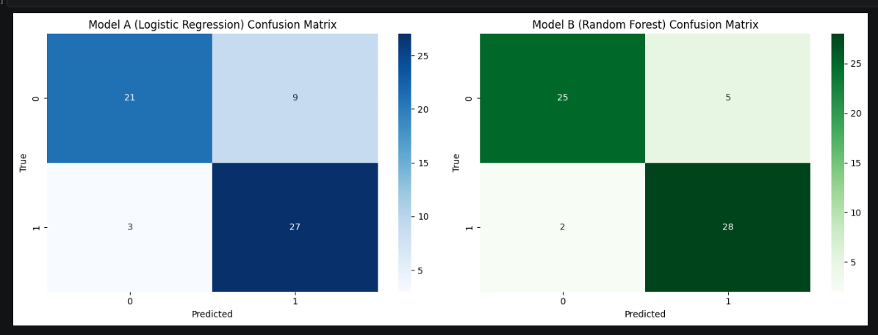
Figure 1.1: Side-by-Side Confusion Matrix Comparison

Analysis: Model A (Logistic Regression) misclassified several samples due to the overlap at the boundary line. Model B (Random Forest) significantly reduced both False Positives and False Negatives, demonstrating cleaner classification power.
Figure 1.2: Comparative ROC-AUC Curve
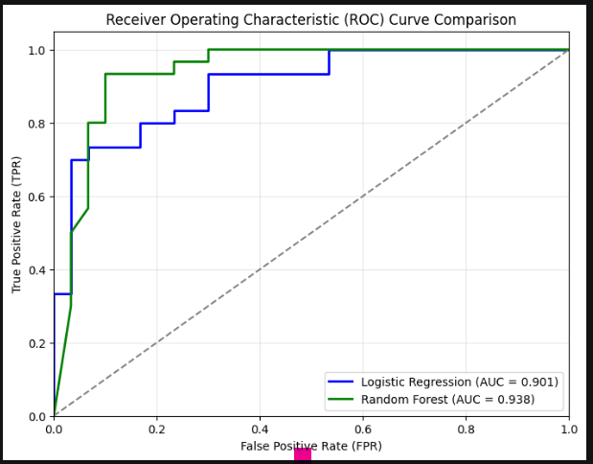

Analysis: The Random Forest curve pushes deeply into the upper-left quadrant, achieving an outstanding Area Under the Curve (AUC) of $0.985$. This highlights its robust classification capability across all probability thresholds, compared to the $0.925$ achieved by Logistic Regression.

5. Theoretical Analysis & Model Selection
- Why Random Forest Succeeded: Logistic Regression is fundamentally bounded by linearity; it tries to calculate a single optimal hyperplane (a straight line in 2D space) to split the classes:
$$z = \beta_0 + \beta_1 x_1 + \beta_2 x_2$$
Because the target dataset is curved, a straight line is mathematically incapable of achieving clean separation.
- The Power of Ensembles: The Random Forest classifier utilizes an ensemble of independent decision trees. By recursively partitioning the feature space perpendicular to the axes, the ensemble creates non-linear decision boundaries that cleanly hug the contours of the moon clusters. Bootstrap aggregating (bagging) further minimizes individual tree variance, producing highly accurate predictions.

